The content of the Tech-Check Lists is based on our specs and MASTERSPEC®

tech-check specs architectural I Division 07

This is a template, so some items will apply to your project, and others won’t or will be missing.

When using the list, make the changes needed for your project.

DIVISION 07 - THERMAL AND MOISTURE PROTECTION
◻ | 071413 - HOT FLUID-APPLIED RUBBERIZED ASPHALT WATERPROOFING SYSTEM and DECK PAVERS
- This section specifies a waterproofing assembly for balconies and terraces above grade with occupied space underneath, including pavers and planters.
- System is single source responsibility, including planting materials (soil and all that) and pavers.
- Coordinate with plumbing for irrigation system and drainage.
- Check warranty covers entire system.
- Basis of Design Waterproofing System Manufacturer: American Hydrotech, Inc., 303 East Ohio Street, Chicago, Illinois 60611-3318, 800-877-6125 or 312-337-4998, http://www.hydrotechusa.com.
- Basis of Design Paver and Pedestals Manufacturer: Hanover Architectural Products, http://www.hanoverpavers.com.
- Comparable Products by Tremco.
- Coordinate with landscape for plants and planting components (soils, etc.)
- Testing for leaks is required.
- LEED PROJECTS: Requirements and Submittals included at the beginning of the section.
◻ | 071616 - CRYSTALLINE WATERPROOFING
- This section specifies crystalline waterproofing which works by penetrating into the concrete or CMU tunnel-like voids, reacting with the concrete components and water and filling-in the capillaries to prevent penetration of water. This waterproofing may be applied to the surface of the concrete or added in the admixture.
- Basis of Design Manufacturer: Xypex.
- If mockups are required, check requirement in the section and show location on the Drawings.
- Testing and inspecting by manufacturer in large or critical applications is required.
- LEED PROJECTS: Requirements and Submittals included at the beginning of the section.
◻ | SECTION 071700 - BENTONITE WATERPROOFING
- This section specifies bentonite waterproofing which can be applied to concrete or installed against soil and then the concrete is poured against it. Bentonite membranes work by expanding when wet, so this insulation cannot be exposed to rain.
- System is single source responsibility.
- System includes protection boards and drainage panels.
- Check warranty covers entire system.
- Basis of Design System Manufacturer: Paraseal by Tremco.
- Installation in the spec matches the Drawings.
- Testing for leaks is required.
- LEED PROJECTS: Requirements and Submittals included at the beginning of the section. LEED PROJECTS: Requirements and Submittals included at the beginning of the section.
◻ | 071800 - TRAFFIC COATINGS
- This section specifies traffic coatings of three types: Interior for M/E rooms, exterior for balconies and terraces over occupied space, and exterior for vehicular traffic at garages. .
- Railings are shop-primed and painted in interiors and galvanized and field painted in exteriors.
- The details should match the spec. In exterior locations, if not using base caps for posts, show base sloping away from the posts.
- LEED PROJECTS: Requirements and Submittals included at the beginning of the section.
◻ | 071900 - WATER REPELLENTS
- This section specifies water repellents which are applied at the surface of concrete or masonry. The basis of design product is a penetrating repellent and will not change the appearance of the concrete or masonry surface.
- Basis of Design Product: PROSOCO Consolideck® SLX100® Water & Oil Repellent.
- Avoid film-forming products, they do not last and might change the appearance of the concrete or masonry.
- ALWAYS include field sample to make sure the repellent will not change the appearance of the concrete or masonry and that it works (water should “bead”).
- Repellents have to be reapplied for maintenance. Ask manufacturer how often according to each case so Owner knows.
- LEED PROJECTS: Requirements and Submittals included at the beginning of the section.
◻ | 072726 - FLUID-APPLIED MEMBRANE AIR BARRIERS
- This section for decorative metal fabrications (i.e.metal reveals) made from steel, copper, bronze, stainless steel, nickel, and brass.
- Finish type is included in this section. Color and sheen might be scheduled on the Drawings or included here.
- Check finishes in the spec section.
- When selecting finishes, talk to the specifier.
- If mockups are required, check requirement in the section and show location on the Drawings.
- Check samples required by the section to make sure that is what you want.
- LEED PROJECTS: Requirements and Submittals included at the beginning of the section.
◻ | 074113.16 - STANDING-SEAM METAL ROOF PANELS
- This section specifies standing seam steal or aluminum roof panels with exposed fasteners.
- Panel Basis of Design Manufacturer: AEP Span.
- Self Adhered Underlayment Basis of Design Product: Grace Ice & Water Shield® HT.
- Felt Underlayment at Field Basis of Design Product: Super Jumbo Tex 60 Minute.
- Roof metal panels are of two types; check that panel type selected is correct for the project’s application:
- Structural: These panels can span from support to support without need of a substrate.
- Architectural: These panels are required to be installed over sheathing with an underlayment over it, self adhering at the perimeter and felt on the field.
- If calculations are needed, these are usually by the structural engineer. If “delegated design” is required, include the structural parameters in the Delegated Design Section.
- Finish type is included in this section, either galvanized or coated - both are shop-applied.
- Check samples required by the section to make sure that is what you want.
- Check that warranties required are included.
- Check that details showing installation match the section.
- LEED PROJECTS: Requirements and Submittals included at the beginning of the section.
◻ | 074113.13 - FORMED METAL ROOF PANELS
- This section is for metals fabricated with sheet metals by folding. They can be field fabricated (the fabrication machinery is brought to the field) or shop fabricated.
- Glass is at least 1/2 thick for full panels.
- Glass is labeled “safety glass”, either fully tempered or laminated.
- If calculations are needed, these are by the fabricator (delegated design - preferred)) or by the structural engineer.
- If delegated design, include structural parameters in the delegated design section.
- Finish type is included in this section.
- If mockups are required, check requirement in the section and show location on the Drawings.
- Check samples required by the section to make sure that is what you want.
- Check that details showing installation match section.
- LEED PROJECTS: Requirements and Submittals included at the beginning of the section.
◻ | 074213.13 - FORMED METAL WALL PANELS
- This section for railings fabricated with metal components and glass inserts or glass supporting panels by a fabricator (i.e. C.R. Laurence Co., Inc.) or custom designed .
- Metal panels for the roof screen perforated or solid steel panels, pre-finished:
- Basis of Design Manufacturer: Morin (Kingspan).
- Glass is labeled “safety glass”, either fully tempered or laminated.
- If calculations are needed, these are by the fabricator (delegated design - preferred)) or by the structural engineer.
- If delegated design, include structural parameters in the delegated design section.
- Finish type is included in this section.
- If mockups are required, check requirement in the section and show location on the Drawings.
- Check samples required by the section to make sure that is what you want.
- Check that details showing installation match section.
- LEED PROJECTS: Requirements and Submittals included at the beginning of the section.
◻ | 074213.23 - METAL COMPOSITE MATERIAL WALL PANELS
- This section for decorative metal fabrications made from sheet metal which is folded, shaped, perforated, etc. Metal can be steel, copper, bronze, stainless steel, nickel, and brass.
- If calculations are needed, these are by the fabricator (delegated design) or by the structural engineer.
- If delegated design, include structural parameters in the delegated design section.
- Finish type is included in this section. Color and sheen might be scheduled on the Drawings or included here.
- Finishes should be preferably shop applied.
- Check finishes in the spec section.
- Check that details showing installation match section.
- LEED PROJECTS: Requirements and Submittals included at the beginning of the section.
◻ | 075419 - POLYVINYL-CHLORIDE (PVC) ROOFING
- This section mainly is for concealed carpentry used for supporting, shimming, or other auxiliary functions.
- Miscellaneous carpentry is tagged either as preservative treated (i.e., when in touch with concrete) or fire-retardant treated where required by code (i.e. concealed blocking or nailers).
- Wood is either fire-rated or preservative-treated, not both.
- Plywood utility panels are tagged as fire-treated and not painted so marks are legible for inspection.
- LEED PROJECTS: Requirements and Submittals included at the beginning of the section.
◻ | 075423 - THERMOPLASTIC-POLYOLEFIN (TPO) ROOFING
- This section mainly is for concealed carpentry used for supporting, shimming, or other auxiliary functions.
- Miscellaneous carpentry is tagged either as preservative treated (i.e., when in touch with concrete) or fire-retardant treated where required by code (i.e. concealed blocking or nailers).
- Wood is either fire-rated or preservative-treated, not both.
- Plywood utility panels are tagged as fire-treated and not painted so marks are legible for inspection.
- LEED PROJECTS: Requirements and Submittals included at the beginning of the section.
◻ | 076200 - SHEET METAL FLASHING AND TRIM
- Grade is AWI Premium.
- Construction: Frameless.
- Door and Drawer Front: Flush overlay.
- Exposed Surfaces: Wood Veneer - Include the following in the specs or the drawings:
- If in the Project there is paneling with the same veneer, tab the cabinetwork veneer as “Match Paneling.”
- Otherwise, the following note in the drawings or specs:
- Exposed surfaces:
- Wood species.
- Cut.
- Grain direction.
- Matching of veneer leaves.
- Veneer matching within the panel face.
- Semi-exposed surfaces: Melamine (thermoset decorative panels).
- Finishes are shop applied:
- Transparent Finish: Pre-catalyzed lacquer.
- Sheen: Flat, satin, semi-gloss, gloss.
- Transparent finish is either clear or stained to add color.
- Cores are MDF:
- Basis of Design Product: MDF by Rosebug, formaldehyde-free.
- LEED PROJECTS: Requirements and Submittals included at the beginning of the section.
◻ | 077100 - ROOF SPECIALTIES
- Grade is AWI Custom.
- Construction: Frameless.
- Door and Drawer Front: Flush overlay.
- Exposed Surfaces:
- Exposed surfaces: Plastic Laminate - grades are indicated in the specs.
- Semi-exposed surfaces: Melamine (thermoset decorative panels).
- Cores are MDF:
- Basis of Design Product: MDF by Rosebug, formaldehyde-free.
- LEED PROJECTS: Requirements and Submittals included at the beginning of the section.
◻ | 077200 - ROOF ACCESSORIES
- Size and type of samples are applicable to the Project.
- If mockups are required, description is in the specs, location is in the Drawings.
- Paneling Rules: If there is other woodwork in the project with the same veneer as the paneling, the woodwork veneer in the other locations is described as “Match Paneling”.
- Grade is AWI Premium.
- Joints: Reveal size or describe inserts.
- Frames.
- Wood Veneer - Include the following in the specs or the drawings:
- Wood species.
- Cut.
- Grain direction.
- Matching of veneer leaves.
- Veneer matching within the panel face.
- Finishes are shop applied:
- Transparent Finish: Pre-catalyzed lacquer.
- Sheen: Flat, satin, semi-gloss, gloss.
- Transparent finish is either clear or stained to add color.
- Cores are MDF:
- Basis of Design Product: MDF by Rosebug, formaldehyde-free.
- Hanging is by Z clips (preferable) or wood.
- LEED PROJECTS: Requirements and Submittals included at the beginning of the section.
◻ | 077273 - VEGETATED ROOF SYSTEMS
- This section is for wall panels at utilitarian spaces like janitor closets.
  - Basis of Design Manufacturer: Marlite FRP Wall Panels.
- Include color and type of panels in the Drawings.
- LEED PROJECTS: Requirements and Submittals included at the beginning of the section.
◻ | 078100 - APPLIED FIREPROOFING
- This section is for wood wall base and miscellaneous trim, including frames.
- If wood base is at wood-veneer-paneling, core is MDF and AWI Grade and veneer match paneling.
- NOTE: Solid wood looks different from veneer - cuts are not the same, so it does not look the same.
- If wood base is not at wood paneling:
- Veneered Trim: Core is MDF and veneer is your choice.
- AWI Grade Custom or Premium.
- Transparent Finish: Pre-catalyzed lacquer.
- Solid Wood Trim: Indicate species, transparent finish as above.
- AWI Grade Custom or Premium.
- Opaque Finish: MDF, painted.
- AWI Grade: Custom.
- LEED PROJECTS: Requirements and Submittals included at the beginning of the section.
◻ | 078123 - INTUMESCENT FIREPROOFING
- This section mainly is for concealed carpentry used for supporting, shimming, or other auxiliary functions.
- Miscellaneous carpentry is tagged either as preservative treated (i.e., when in touch with concrete) or fire-retardant treated where required by code (i.e. concealed blocking or nailers).
- Wood is either fire-rated or preservative-treated, not both.
- Plywood utility panels are tagged as fire-treated and not painted so marks are legible for inspection.
- LEED PROJECTS: Requirements and Submittals included at the beginning of the section.
◻ | 078413 - PENETRATION FIRESTOPPING
- This section mainly is for concealed carpentry used for supporting, shimming, or other auxiliary functions.
- Miscellaneous carpentry is tagged either as preservative treated (i.e., when in touch with concrete) or fire-retardant treated where required by code (i.e. concealed blocking or nailers).
- Wood is either fire-rated or preservative-treated, not both.
- Plywood utility panels are tagged as fire-treated and not painted so marks are legible for inspection.
- LEED PROJECTS: Requirements and Submittals included at the beginning of the section.
◻ | 078443 - JOINT FIRESTOPPING
- Grade is AWI Premium.
- Construction: Frameless.
- Door and Drawer Front: Flush overlay.
- Exposed Surfaces: Wood Veneer - Include the following in the specs or the drawings:
- If in the Project there is paneling with the same veneer, tab the cabinetwork veneer as “Match Paneling.”
- Otherwise, the following note in the drawings or specs:
- Exposed surfaces:
- Wood species.
- Cut.
- Grain direction.
- Matching of veneer leaves.
- Veneer matching within the panel face.
- Semi-exposed surfaces: Melamine (thermoset decorative panels).
- Finishes are shop applied:
- Transparent Finish: Pre-catalyzed lacquer.
- Sheen: Flat, satin, semi-gloss, gloss.
- Transparent finish is either clear or stained to add color.
- Cores are MDF:
- Basis of Design Product: MDF by Rosebug, formaldehyde-free.
- LEED PROJECTS: Requirements and Submittals included at the beginning of the section.
- This section mainly is for concealed carpentry used for supporting, shimming, or other auxiliary functions.
- Miscellaneous carpentry is tagged either as preservative treated (i.e., when in touch with concrete) or fire-retardant treated where required by code (i.e. concealed blocking or nailers).
- Wood is either fire-rated or preservative-treated, not both.
- Plywood utility panels are tagged as fire-treated and not painted so marks are legible for inspection.
- LEED PROJECTS: Requirements and Submittals included at the beginning of the section.
- This section mainly is for concealed carpentry used for supporting, shimming, or other auxiliary functions.
- Miscellaneous carpentry is tagged either as preservative treated (i.e., when in touch with concrete) or fire-retardant treated where required by code (i.e. concealed blocking or nailers).
- Wood is either fire-rated or preservative-treated, not both.
- Plywood utility panels are tagged as fire-treated and not painted so marks are legible for inspection.
- LEED PROJECTS: Requirements and Submittals included at the beginning of the section.
◻ | 079200 - JOINT SEALANTS
- This section mainly is for concealed carpentry used for supporting, shimming, or other auxiliary functions.
- Miscellaneous carpentry is tagged either as preservative treated (i.e., when in touch with concrete) or fire-retardant treated where required by code (i.e. concealed blocking or nailers).
- Wood is either fire-rated or preservative-treated, not both.
- Plywood utility panels are tagged as fire-treated and not painted so marks are legible for inspection.
- LEED PROJECTS: Requirements and Submittals included at the beginning of the section.
◻ | 079513.13 - INTERIOR EXPANSION JOINT COVER ASSEMBLIES
- The expansion joint cover assemblies sections specify joint covers at expansion joints that go up, across, and down a building like cake cuts. Basically, you can consider these joints as dividing two buildings standing very close to each other. The exterior covers are placed around the exterior of the building (envelope-roof-envelope and grade slab), at the equivalent interior sides of these joints. The interior joint covers are placed at the in-line interior joints: floor to floor, ceiling to ceiling, partition to partition, on both sides of the joints. Expansion joints allow buildings to move with thermal changes, the wind, and earthquakes. They are fire-rated or not and should be carefully chosen according to the type and amount of movement expected, materials, and transitions.
- Basis of Design Manufacturers: Construction Specialties.
- ALWAYS talk to the manufacturer when choosing a joint cover.
- Ask the structural engineer the amount of movement expected (including floor drift). Include in the “Delegated Design” section. Preferably joints should be single-sourced by type (roof, building envelope, interiors, etc.)
- Consider transitions between vertical and horizontal joint covers.
- A joint cover schedule is added at the end of the section. Tags are the same as in the Drawings.
◻ | 079513.16 - EXTERIOR EXPANSION JOINT COVER ASSEMBLIES
- The expansion joint cover assemblies sections specify joint covers at expansion joints that go up, across, and down a building like cake cuts. Basically, you can consider these joints as dividing two buildings standing very close to each other. The exterior covers are placed around the exterior of the building (envelope-roof-envelope and grade slab), at the equivalent interior sides of these joints. The interior joint covers are placed at the in-line interior joints: floor to floor, ceiling to ceiling, partition to partition, on both sides of the joints. Expansion joints allow buildings to move with thermal changes, the wind, and earthquakes. They are fire-rated or not and should be carefully chosen according to the type and amount of movement expected, materials, and transitions.
- Basis of Design Manufacturers: Construction Specialties, JM for roof joints.
- ALWAYS talk to the manufacturer when choosing a joint cover.
- Ask the structural engineer the amount of movement expected (including floor drift). Include in the “Delegated Design” section. Preferably joints should be single-sourced by type (roof, building envelope, interiors, etc.)
- Consider transitions between vertical and horizontal joint covers.
- A joint cover schedule is added at the end of the section. Tags are the same as in the Drawings.
◻ | 079513.19 - PARKING DECK EXPANSION JOINT COVER ASSEMBLIES
- The expansion joint cover assemblies sections specify joint covers at expansion joints that go up, across, and down a building like cake cuts. Basically, you can consider these joints as dividing two buildings standing very close to each other. In the case of Garages, expansion joint covers are typically only required at the top of the decks.
- Expansion joints allow buildings to move with thermal changes, the wind, and earthquakes. They are fire-rated or not and should be carefully chosen according to the type and amount of movement expected, materials, and transitions.
- Basis of Design Manufacturers: Construction Specialties.
- ALWAYS talk to the manufacturer when choosing a joint cover.
- Ask the structural engineer the amount of movement expected (including floor drift). Include in the “Delegated Design” section. Preferably joints should be single-sourced by type (roof, building envelope, interiors, etc.)
- Consider transitions between vertical and horizontal joint covers.
- A joint cover schedule is added at the end of the section. Tags are the same as in the Drawings.

END OF TECH-CHECK LIST

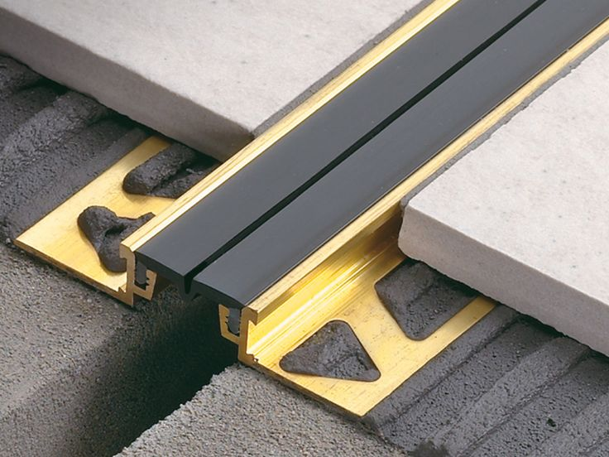
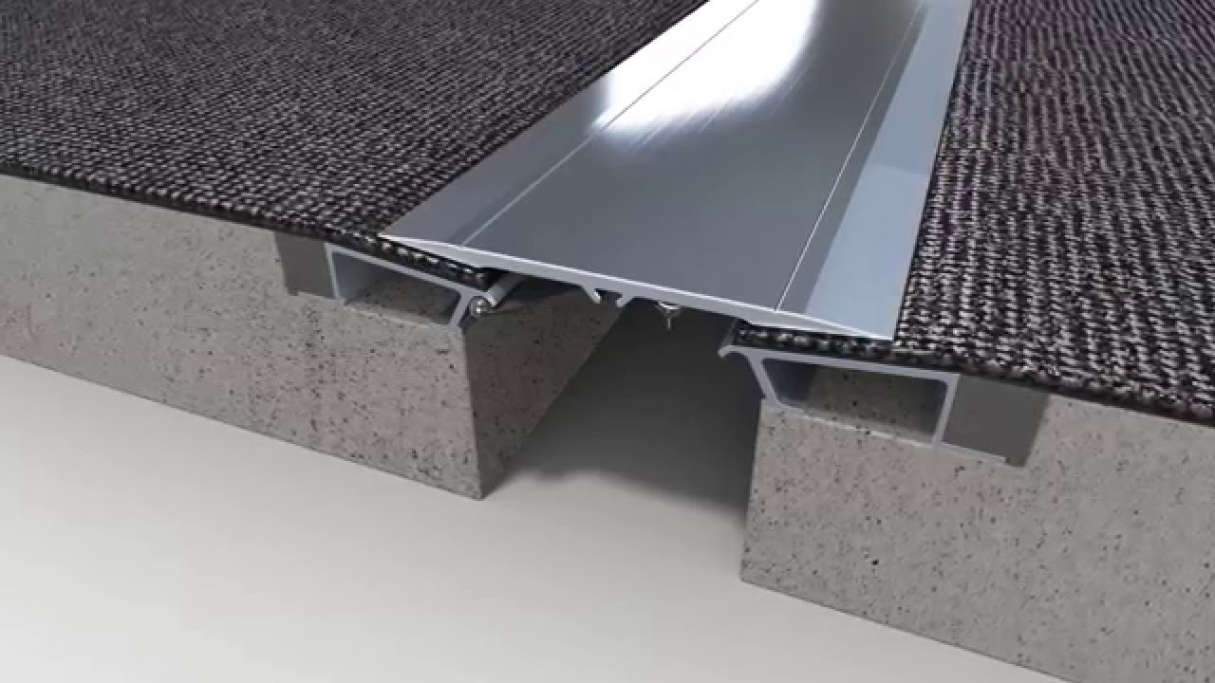
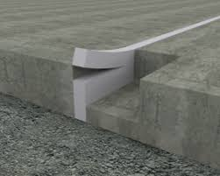
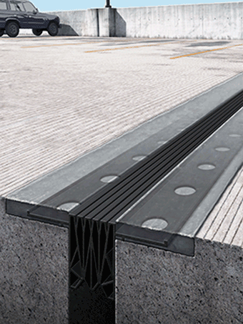
expANSION JOINTS

