The content of the Tech-Check Lists is based on our specs and MASTERSPEC®.

tech-check specs architectural I Division 08

This is a template, so some items will apply to your project, and others won’t or will be missing.

When using the list, make the changes needed for your project.
◻ | 081113 - HOLLOW METAL DOORS AND FRAMES
 | - This section specifies steel doors and frames, rated and non-rated, non-insulated, interior and exterior door frames and doors, galvanized for exteriors and shop primed for interiors, to be field painted.  - Basis of Design Manufacturer: Assa Abloy (CECO or Curries)  - Section includes fire-rated doors when required by code.  - Borrowed-lites are included in the section if in the project.  - LEED PROJECTS: Requirements and Submittals included at the beginning of the section. | 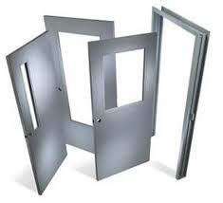
◻ | 081216 - ALUMINUM FRAMES
 | - This section specifies interior clear anodized doors and side-lights fames.  - Basis of Design Manufacturer: Raco (only for one panel, no insulating glass)  - Section includes fire-rated frames (up to 1 hour) when required by code.  - Borrowed-lites are included in the section if in the project.  - LEED PRements and Submittals included at the beginning of the section. | 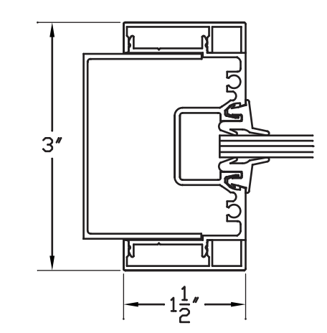
◻ | 081416 - FLUSH WOOD DOORS
 | - This section specifies flush wood doors with opaque finish (paint), veneered faces, or plastic laminate faces.  - Basis of Design Manufacturer: Eggers or Marshfield (Masonite)  - Cores are MEF for non-rated doors and particleboard or mineral core for rated.  - Painted doors are AWI Custom Grade with MDF faces.  - Finish Type is specified.  - Wood veneered doors are AWI Custom Grade except for posh projects, specify Premium Grade.  - Veneer species, cut and placement of veneer next to each other and within the face f the doors is specified.  - Finish is specified.  - If veneered door is within a wood panel room or wall, this is indicated in the specs.  - Acoustics performance requirements are specified if needed.  - LEED PROJECTS: Requirements and Submittals included at the beginning of the section. | 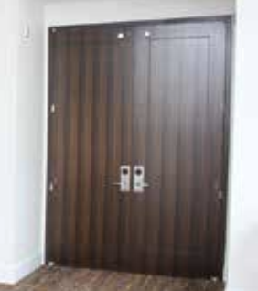
◻ | 083113 - ACCESS DOORS AND FRAMES
 | - This section specifies access panels and frames, steel to be field painted  - Basis of Design Manufacturers typical units: Larsen’s or JL Industries.  - Basis of Design Manufacturers for gypsum board ceilings at public areas: Intexforms.  - Location of panels is not know until construction.  - Rated requirements and products are included unless there are no rated assemblies in the project.  - Locks are specified if required.  - LEED PROJECTS: Requirements and Submittals included at the beginning of the section. | 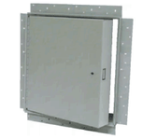
◻ | 083216 - SLIDING ALUMINUM-FRAMED GLASS DOORS
 | - This section specifies sliding aluminum-framed doors for exterior locations.  - Basis of Design Manufacturers: CRL, Kawneer; Oldcastle. https://www.kawneer.com/kawneer/north_america/en/product.asp?cat_id=1343&prod_id=1846&desc=sliding-track-mall-storefront-door-panel  - Performance requirements are included.  - Glazing is included (these are glazed by the manufacturer).  - Hardware is included in the section or it is in the Drawings.  - Finish is included.  - Details match product selected.  - LEED PROJECTS: Requirements and Submittals included at the beginning of the section. | 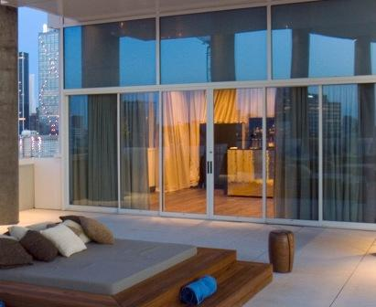
◻ | 083323 - OVERHEAD COILING DOORS
 | - This section specifies overhead coiling doors manually or motor operated, fire rated or not, for exteriors and interiors, shop finished.  - Basis of Design Manufacturer: Overhead Doors (Cookson). https://www.overheaddoor.com/rolling-steel-service-doors  - If possible, require single source responsibility for coiling and sectional doors in the project.  - Performance requirements are included.  - If motor operated, coordination with electrical work requirement is included.  - If rated, fire rating requirements are included.  - Curtain door of specified model is described.  - Insulated is specified at exterior doors with at occupied interior spaces.  - Locking devices are included and hopefully coordinated with Owner.  - Shop finish is specified and color selected (or “selected from manufacturer’ standard colors” added). Custom colors are expensive.  - LEED PROJECTS: Requirements and Submittals included at the beginning of the section. | 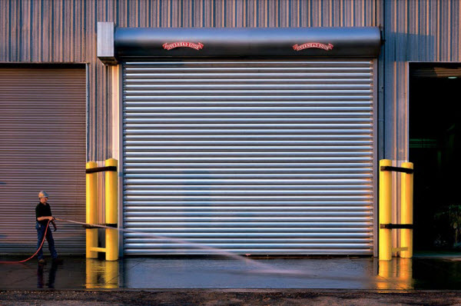
◻ | 083613 - SECTIONAL DOORS
 | - This section specifies manually or motor operated sectional doors (there are not fire-rated sectional doors), steel only.  - Basis of Design Manufacturer: Overhead Doors (Cookson). https://www.overheaddoor.com/rolling-steel-service-doors  - If possible, require single source responsibility for coiling and sectional doors in the project.  - Performance requirements are included.  - If motor operated, coordination with electrical work requirement is included.  - Curtain door of model selected is described.  - Insulated is specified at exterior doors with at occupied interior spaces.  - If vision panels are required they are included in the spec.  - Locking devices are included and hopefully coordinated with Owner.  - Shop finish is specified and color selected (or “selected from manufacturer’ standard colors” added). Custom colors are expensive.  - LEED PROJECTS: Requirements and Submittals included at the beginning of the section. | 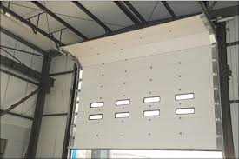
◻ | 084113 - ALUMINUM-FRAMED ENTRANCES AND STOREFRONTS
 | - This section specifies storefront framing and manual-swing entrances.  - Basis of Design Manufacturers: Kawneer and Oldcastle. https://www.kawneer.com/kawneer/north_america/en/product_category.asp?cat_id=1342&desc=fixed-aluminum-framing-storefront-glazing-systems  - If possible, require single source responsibility for all the glazed assemblies in the building envelope.  - Energy performance requirements are specified.  - Structural and other performance requirements are included.  - Only systems with thermal performance systems are OK for exterior applications.  - If calculations are needed, these are usually by the fabricator. If “delegated design” is required, include the structural parameters in the Delegated Design Section.  - Finish type is included - color for coatings and type of anodized (clear, black, etc.)  - Check samples required by the section to make sure that is what you want.  - Check that warranties required are included.  - Check that details storefront, entrances, and installation match the section.  - Entrance door is specified with the right rating (medium use, use type, hardware, finish)  - Type of glass and glass position (center, back, front) in the frame is specified.  - Field testing is included.  - Butt joints (if any): Silicone sealant is specified.  - LEED PROJECTS: Requirements and Submittals included at the beginning of the section. | 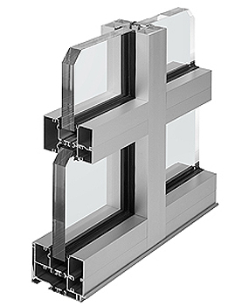
◻ | 084116 - ALL-GLASS ENTRANCES AND STOREFRONTS
 | - This section specifies storefront framing and manual-swing entrances.  - Basis of Design Manufacturers: Kawneer and Oldcastle. https://www.kawneer.com/kawneer/north_america/en/product_category.asp?cat_id=1342&desc=fixed-aluminum-framing-storefront-glazing-systems  - If possible, require single source responsibility for all the glazed assemblies in the building envelope.  - Energy performance requirements are specified.  - Structural and other performance requirements are included.  - Only systems with thermal performance systems are OK for exterior applications.  - If calculations are needed, these are usually by the fabricator. If “delegated design” is required, include the structural parameters in the Delegated Design Section.  - Finish type is included - color for coatings and type of anodized (clear, black, etc.)  - Check samples required by the section to make sure that is what you want.  - Check that warranties required are included.  - Check that details storefront, entrances, and installation match the section.  - Entrance door is specified with the right rating (medium use, use type, hardware, finish)  - Type of glass and glass position (center, back, front) in the frame is specified.  - Field testing is included.  - Butt joints (if any): Silicone sealant is specified.  - LEED PROJECTS: Requirements and Submittals included at the beginning of the section. | 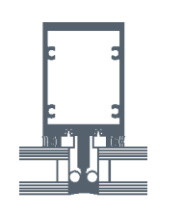
◻ | 084213 - ALUMINUM-FRAMED ENTRANCES
 | - This section specifies aluminum-framed manual-swing entrances for exteriors.  - Basis of Design Manufacturers: US Aluminum, Kawneer and Oldcastle. https://www.kawneer.com/kawneer/north_america/en/product_category.asp?cat_id=1339&desc=commercial-aluminum-swing-door-entrance-systems  - If possible, require single source responsibility for all the glazed assemblies in the building envelope.  - Energy performance requirements are specified.  - Traffic requirement is included (Moderate or High)  - Finish type is included - color for coatings and type of anodized (clear, black, etc.)  - Check that warranties required are included.  - Check that details match the section.  - Hardware is specified.  - Type of stile (medium or Wide only, no Narrow because hardware does not fit)  - Type of glass and glass position (center, back, front) in the frame is specified.  - LEED PROJECTS: Requirements and Submittals included at the beginning of the section. | 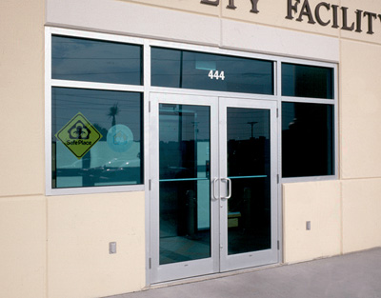
◻ | 084226 - ALL-GLASS ENTRANCES
 | - This section specifies frameless manual-swing entrances for exteriors.  - Basis of Design Manufacturers: CRL (these are Blumcraft), Kawneer and Oldcastle. http://www.crl-arch.com/product_page/doors_entrances/glass_entrance_doors.html  - If possible, require single source responsibility for all the glazed assemblies in the building envelope.  - Metal components finish is included.  - Check that warranties required are included.  - Check that details match the section.  - Hardware is specified (comes with the door).  - Type of glass is specified (comes with the door).  - LEED PROJECTS: Requirements and Submittals included at the beginning of the section. | 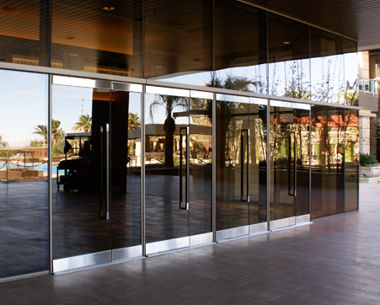
◻ | 084413 - glazed-aluminum curtain walls
 | - This section specifies aluminum framed traditional or unitized curtain wall systems.  - Basis of Design Manufacturers: Kawneer and Oldcastle. https://www.kawneer.com/kawneer/north_america/en/product.asp?cat_id=1992&prod_id=1805&desc=thermal-break-ssg-aluminum-curtain-walls  - If possible, require single source responsibility for all the glazed assemblies in the building envelope.  - Energy performance requirements are specified.  - Structural and other performance requirements are included.  - Only systems with thermal performance systems are OK for exterior applications.  - If calculations are needed, these are usually by the fabricator. If “delegated design” is required, include the structural parameters in the Delegated Design Section.  - Finish type is included - color for coatings and type of anodized (clear, black, etc.)  - Check samples required by the section to make sure that is what you want.  - Check that warranties required are included.  - Check that the section matches the curtain wall details curtain and installation.  - Type of glass and glass position (center, back, front) in the frame is specified.  - Field testing is included.  - LEED PROJECTS: Requirements and Submittals included at the beginning of the section. | 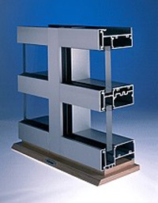
◻ | 084423 - structural-sealant-glazed curtain walls
 | - This section specifies curtain wall with butt joints (vertical, horizontal, or both ways) traditional or unitized curtain wall systems.  - Basis of Design Manufacturers: Kawneer and Oldcastle. https://www.kawneer.com/kawneer/north_america/en/product_filter.asp?cat_id=1992  - If possible, require single source responsibility for all the glazed assemblies in the building envelope.  - Energy performance requirements are specified.  - Structural and other performance requirements are included.  - Only systems with thermal performance systems are OK for exterior applications.  - If calculations are needed, these are usually by the fabricator. If “delegated design” is required, include the structural parameters in the Delegated Design Section.  - Finish type is included - color for coatings and type of anodized (clear, black, etc.)  - Check samples required by the section to make sure that is what you want.  - Check that warranties required are included.  - Check that the section matches the curtain wall details curtain and installation.  - Type of glass is specified.  - Field testing is included.  - LEED PROJECTS: Requirements and Submittals included at the beginning of the section. | 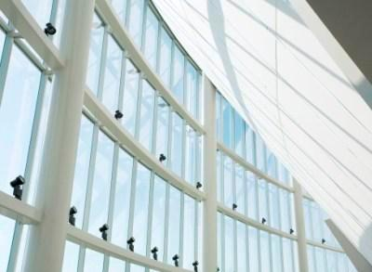
◻ | 084523 - fiberglass-sandwich-panel assemblies
 | - This section specifies panels for walls, roof, skylights, and canopies.  - Basis of Design Manufacturers: Kalwall. https://www.kalwall.com/kalwall-products/  - If possible, require single source responsibility for all the sandwich assemblies in the building envelope.  - Energy performance requirements are specified.  - Structural and other performance requirements are included.  - If calculations are needed, these are usually by the fabricator. If “delegated design” is required, include the structural parameters in the Delegated Design Section.  - Check that warranties required are included.  - Check that the section matches the details.  - Thickness, grid, both faces and aluminum framing are specified.  - Finishes are included.  - Field testing is included.  - LEED PROJECTS: Requirements and Submittals included at the beginning of the section. | 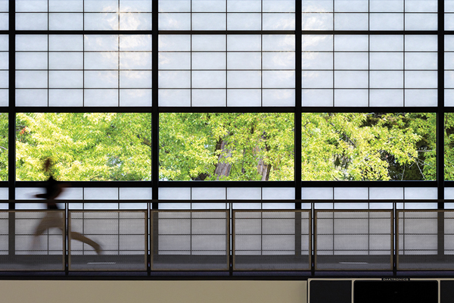
◻ | 086200 - unit skylights
 | - This section specifies plastic unit skylights (domes typically) with INTEGRAL CURBS.  - Basis of Design Manufacturers: Bristolite, http://www.bristolite.com/interfaces/productsummary.aspx?M=2&V=1  - Require single source responsibility for all unit skylights in the project.  - Energy performance requirements are specified.  - Structural and other performance requirements are included.  - Check that warranties required are included.  - Check that the section matches the details.  - Curb, framing, and plastic type are specified.  - Unit size and shape, and finishes are included.  - Structural curbs and safety screens are required.  - Field testing is included.  - LEED PROJECTS: Requirements and Submittals included at the beginning of the section. | 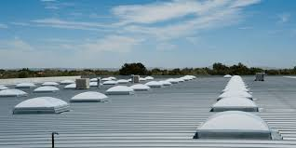
◻ | 086300 - metal-framed skylights
 | - This section specifies plastic unit skylights (domes typically) with INTEGRAL CURBS.  - Basis of Design Manufacturers: Bristolite, http://www.bristolite.com/interfaces/productsummary.aspx?M=2&V=1  - Require single source responsibility for all metal framed skylights in the project.  - Energy performance requirements are specified.  - Structural and other performance requirements are included.  - If calculations are needed, these are usually by the fabricator. If “delegated design” is required, include the structural parameters in the Delegated Design Section.  - Check that warranties required are included.  - Check that the section matches the details.  - Curb, framing, and glass type are specified.  - Unit size and shape, and finishes are included.  - Structural curbs and safety screens are required.  - Field testing is included.  - LEED PROJECTS: Requirements and Submittals included at the beginning of the section. | 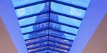
◻ | 087100 - door hardware
- This section specifies mechanical door hardware for swing doors.
- Coordination with electrical work requirement is included.
- Submittal of hardware schedule prepared under the supervision of the Installer Architectural Hardware Consultant requirement is included.
- Warranties are included.
- Performance requirements for fire rated doors, smoke control doors, electrified doors, means of egress doors and accessibility are included.
- The hardware schedule and hardware groups are in the Drawings.
◻ | 088000 - glazing
 | - This section specifies glass in the building envelope.  - Basis of Design Fabricator: Viracon (does not manufacture glass; buys glass from the glass manufacturers and treats it (tempers, cuts, laminates, etc.) and then manufactures the glazing units (insulated glass, etc.) http://www.viracon.com/  - Warranties for each type of glass in the project are included.  - Energy performance requirements are specified.  - Structural and other performance requirements are included.  - If calculations are needed, these are usually by the fabricator. If “delegated design” is required, include the structural parameters in the Delegated Design Section.  - Check that all the glass types in the project are included in the spec.  - Check that there is a schedule at the end of the section.  - Sealants are included.  - LEED PROJECTS: Requirements and Submittals included at the beginning of the section. | 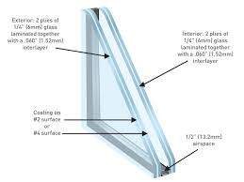
◻ | 088113 - decorative glass glazing
 | - This section specifies decorative glass in the building envelope.  - Warranties for each type of glass in the project are included.  - Energy performance requirements are specified.  - Structural and other performance requirements are included.  - If calculations are needed, these are usually by the fabricator. If “delegated design” is required, include the structural parameters in the Delegated Design Section.  - Check that all the glass types in the project are included in the spec.  - Check that there is a schedule at the end of the section.  - Sealants are included.  - LEED PROJECTS: Requirements and Submittals included at the beginning of the section. | 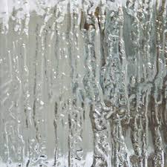
◻ | 088300 - mirrors
 | - This section specifies wall mounted mirrors.  - Warranties for each type of mirror in the project are included.  - For backing of mirrors without lead, see manufacturer’s information.  - If calculations are needed, these are usually by the fabricator. If “delegated design” is required, include the structural parameters in the Delegated Design Section.  - Avoid attaching the mirror only with adhesive; specify mechanical attachments or a combination of mechanical attachments and adhesive.  - Type of safety glazing is specified.  - Trim or edge finish is included.  - LEED PROJECTS: Requirements and Submittals included at the beginning of the section. | 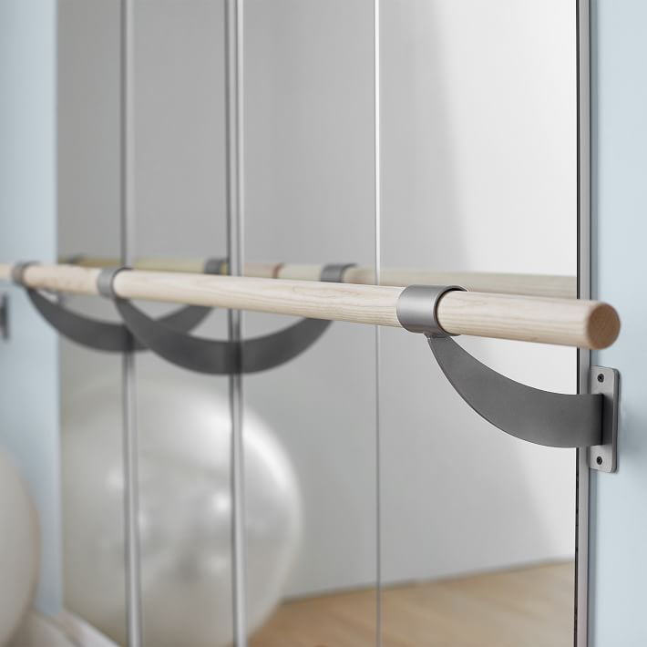
◻ | 088813 - fire-resistant glazing
 | - This section specifies fire-protection (not fire-resistant) glass and framing assemblies.  - Basis of Design Fabricator: Safti-First, fire rating glass and framing. http://safti.com/  - Warranties for each type of glass in the project are included..  - Fire protection requirements are indicated.  - Energy performance requirements are specified.  - Structural and other performance requirements are included.  - If calculations are needed, these are usually by the fabricator. If “delegated design” is required, include the structural parameters in the Delegated Design Section.  - Check that all the glass types in the project are included in the spec.  - Check that there is a schedule at the end of the section.  - Sealants are included.  - LEED PROJECTS: Requirements and Submittals included at the beginning of the section. | 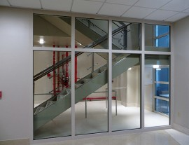
◻ | 089119 - fixed louvers
 | - Coordinate with mechanical consultant for airflow requirements, if needed for the project.  - This section specifies extruded aluminum and formed metal louvers.  - Basis of Design Fabricator: Construction Specialties. https://www.c-sgroup.com/architectural-louvers  - Single source responsibility for all louvers in the project.  - Field measurements requirement is included.  - Finish is included.  - Type of louver in the drawings matches the spec.  - Blank-off panels are included if used.  - LEED PROJECTS: Requirements and Submittals included at the beginning of the section. | 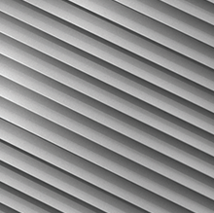

DIVISION 08 - OPENINGS

END OF TECH-CHECK LIST

