The content of the Tech-Check Lists is based on our specs and MASTERSPEC®.

tech-check specs architectural I Division 10

This is a template, so some items will apply to your project, and others won’t or will be missing.

When using the list, make the changes needed for your project.
◻ | 102113.14 - STAINLESS-STEEL TOILET COMPARTMENTS
 | - This section specified stainless steel toilet compartments.  - Basis of Design Manufacturer: Bradley https://www.bradleycorp.com/toiletpartitions/stainless-steel-partitions  - ALL TOILET COMPARTMENTS IN RWW ARE SPECIFIED “OVERHEAD BRACED/FLOOR MOUNTED because that is the type that is easiest to install without wabbles.  - “Verify field dimensions”paragraph is included in the section.  - The product specificed has gap-free option when availlable.  - LEED PROJECTS: Requirements and Submittals included at the beginning of the section. | 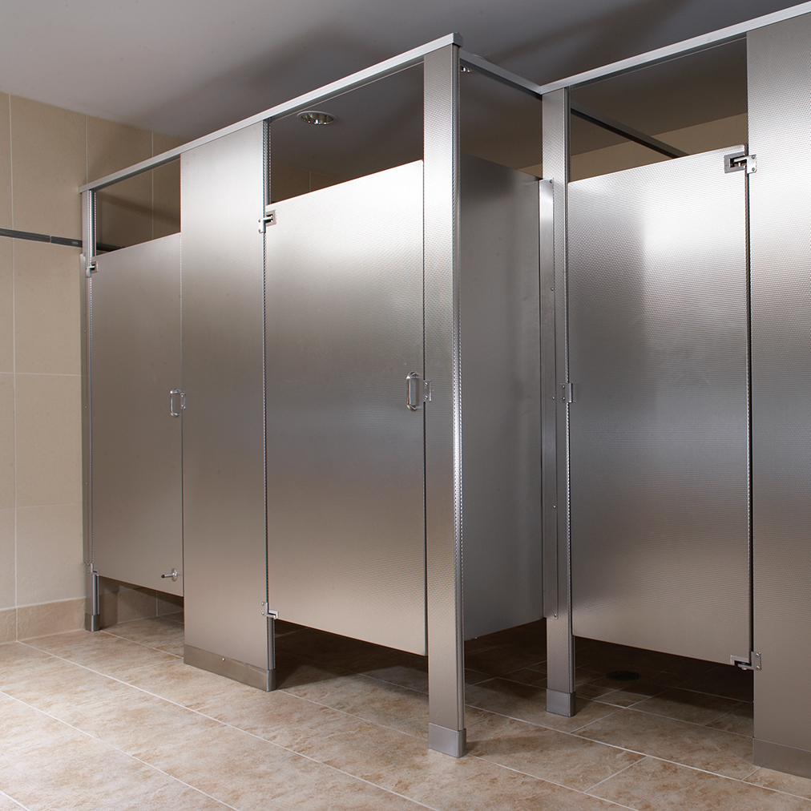
◻ | 102113.17 - PHENOLIC-CORE TOILET COMPARTMENTS
 | - This section specifies phenolic-core toilet compartments.  - Basis of Design Manufacturers: Bobrick or Bradley. https://www.bradleycorp.com/toiletpartitions/solid-phenolic-core-partitions  - ALL TOILET COMPARTMENTS IN RWW ARE SPECIFIED “OVERHEAD BRACED/FLOOR MOUNTED because that is the type that is easiest to install without wabbles.  - “Verify field dimensions”paragraph is included in the section.  - The product specificed has gap-free option when availlable.  - LEED PROJECTS: Requirements and Submittals included at the beginning of the section. | 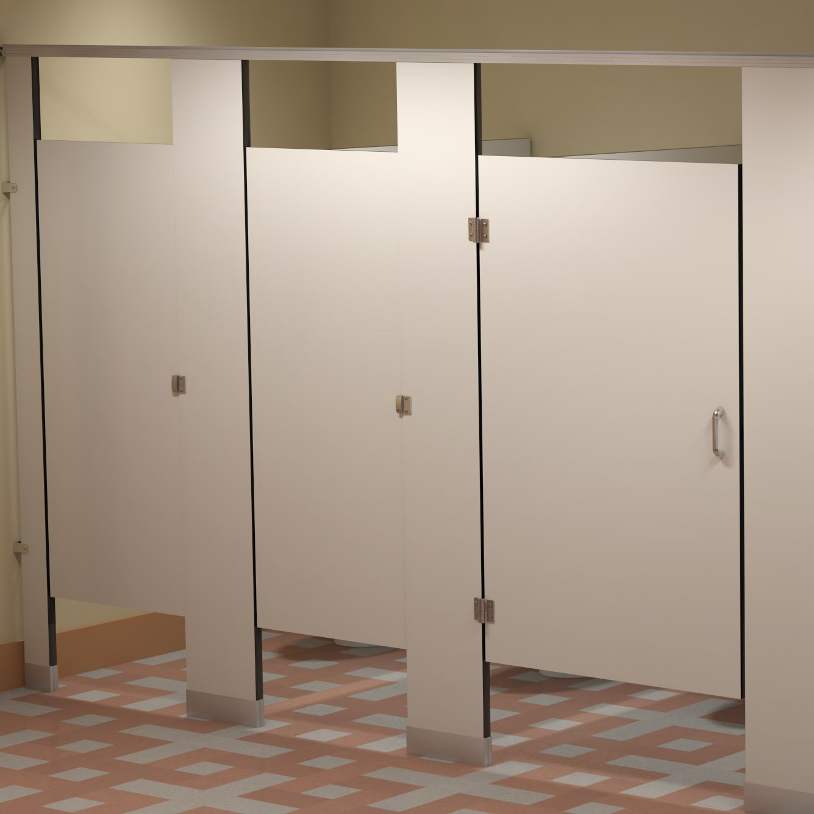
◻ | 104413 - FIRE PROTECTION CABINETS
 | - This section specifies fire protection cabinets for portable fire extinguishers, surface mounted, semi-recessed and fully recessed.  - Basis of Design Manufacturer: Larse’s or JL. http://www.larsensmfg.com/home;  - Section includes white enameled finish (to be field painted to match the wall) or stainless steel - as applicable to project.  - Partition thickness is coordinated with type of cabinet and details. If cabinets are installed in rated partitions, detail is included.  - Installation for type of cabinets specified is included in the section- window (if any), letering, etc.  - FIRE EXTINGUISHERS are typically 5 pounds. | 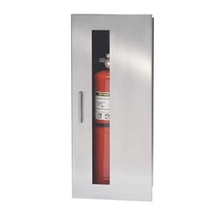
◻ | 102233 - toilet , shower, and custodial accessories
 | - This section specifies accessories for public-use bathrooms and showers; under lavatory guards; and custodial accessories.  - Basis of Design Manufacturer: Bobrick.  - Basis of Design Product under lavatory guards: IPS Truebro® Lav Guard® 2 Undersink Piping Covers  - Section includes the following:  - General requirements for toilet accessories that are shown on the Drawings.  - General requirements for grab bars that are shown on the Drawings.  - Miscellaneous Accessories: Coat hooks, folding shelfs, diaper changing unit.  - Accessories for showers: Curtain rod, curtains shower seat, shelves, towel hooks, towel bar, bench for outside the shower where people undress and dress, hair dryer.  - Accessories for custodial rooms: Floor sink and shelf with mop/broom holder.  - Check that details showing installation and location match the section.  - LEED PROJECTS: Requirements and Submittals included at the beginning of the section. | 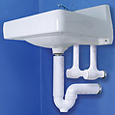

DIVISION 10 - SPECIALTIES

END OF TECH-CHECKING LIST

