The content of the Tech-Check Lists is based on our specs and MASTERSPEC®.

tech-check specs architectural I Division 11

This is a template, so some items will apply to your project, and others won’t or will be missing.

When using the list, make the changes needed for your project.

DIVISION 11 - EQUIPMENT
◻ | 111313 - LOADING DOCK BUMPERS
 | - This section specifies loading dock bumpers. Surface mounted, laminated tread.  - Basis of Design Manufacturer: Rite-Hite. https://www.ritehite.com/en/am/products/loading-dock-management/loading-dock-bumpers  - Check that specified bumpers are the same type as indicated on the Drawings.  - Check that details showing installation and location match the section. | 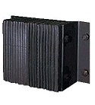
◻ | 111316 - LOADING DOCK SEALS AND SHELTERS
 | - This section specifies transparent-strip door curtains, inflatable loading dock seals, and frame-type shelters.  - Basis of Design Manufacturer: Blue Giant, https://www.bluegiant.com/Products/Seals-and-Shelters.aspx.  - Section includes requirement of coordination with electrical work if units are motor-operated.  - Check that section included sizes if not indicated on the Drawings.  - Section induces types of trip door curtains including installation method.  - Manufacturer’s warranty is included.  - Maintenance service and demonstration are included if Owner wants them.  - LEED PROJECTS: Requirements and Submittals included at the beginning of the section. | 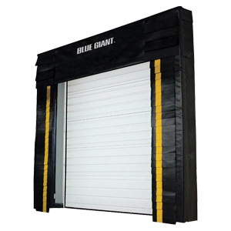
◻ | 111319 - STATIONARY LOADING DOCK EQUIPMENT
 | - This section specifies pit style, hydraulic dock levelers and truck restraints.  - Basis of Design Manufacturer: Blue Giant. https://www.bluegiant.com/Products/Dock-Levelers/Pit-Style.aspx  - Section includes coordination with existing construction and electrical work, if motorized unit is specified.  - Manufacturer’s warranty is included.  - Field measurements requirement is included.  - Accessories are included.  - Truck Restraints are included.  - Maintenance service and demonstration are included if Owner wants them.  - LEED PROJECTS: Requirements and Submittals included at the beginning of the section. | 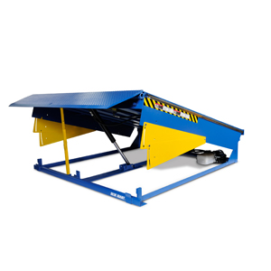
◻ | 111200 - PARKING CONTROL EQUIPMENT
 | - This section specifies Automatic barrier gates.  - Basis of Design Manufacturer: None on file  - Coordination with electrical work is included in the section.  - Type (straight gate arm type) is in the specs.  - Required ADA protections (audible signal, etc) are included in the specs. | 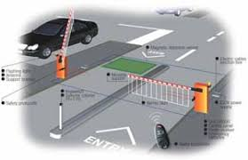

END OF TECH-CHECKING LIST

