The content of the Tech-Check Lists is based on our specs and MASTERSPEC®.

tech-check specs architectural I Division 12

This is a template, so some items will apply to your project, and others won’t or will be missing.

When using the list, make the changes needed for your project.

DIVISION 12 - FURNISHINGS
◻ | 123623.13 - PLASTIC-LAMINATE-CLAD COUNTERTOPS
 | - This section specifies plastic -laminate-clad countertops with MDF cores.  - Basis of Design Manufacturer for Core: ROSEBURG (formerly Sierra Pine)  - Field measurements requirement is included.  - Core: MDF: Moisture resistant, flame retardant and no-added formaldehyde (NAF)  - Description of backsplash and edge in specs matches details.  - LEED PROJECTS: Requirements and Submittals included at the beginning of the section. | 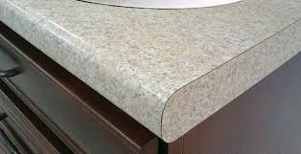
◻ | SECTION 123661.16 - SOLID SURFACING COUNTERTOPS
 | - This section specifies solid surfacing countertops and backsplashes.  - Solid surface material characteristics are included.  - Field measurements requirement is included.  - Description of backsplash and edge in specs matches details.  - Installation instructions match details.  - LEED PROJECTS: Requirements and Submittals included at the beginning of the section. | 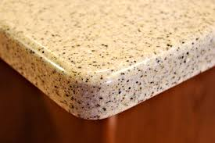
◻ | 123661.19 - QUARTZ AGGLOMERATE COUNTERTOPS
 | - This section specifies quartz countertops and backsplashes.  - Quartz material characteristics are included.  - Field measurements requirement is included.  - Description of backsplash and edge in specs matches details.  - Installation instructions match details.  - LEED PROJECTS: Requirements and Submittals included at the beginning of the section. | 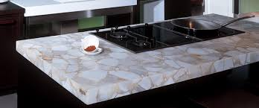
◻ | 124813 - ENTRANCE FLOOR MATS AND FRAMES
 | - This section specifies resilient entrance mats with surface mounted or recessed frames.  - Basis of Design Manufacturer: Construction Specialties.  - Field measurements requirement is included.  - Coordination with concrete work in new buildings with recessed frames is included.  - Description of frames and mats matches the details.  - Installation instructions match details.  - LEED PROJECTS: Requirements and Submittals included at the beginning of the section. | 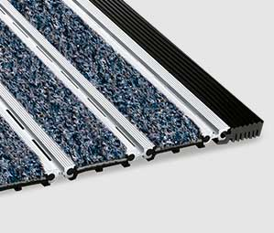
◻ | 124816 - ENTRANCE FLOOR GRILLES
 | - This section specifies resilient entrance mats with surface mounted or recessed frames.  - Basis of Design Manufacturer: Construction Specialties.  - Field measurements requirement is included.  - Coordination with concrete work in new buildings with recessed frames is included.  - Description of frames and grilles in specs matches details.  - Installation instructions match details.  - LEED PROJECTS: Requirements and Submittals included at the beginning of the section. | 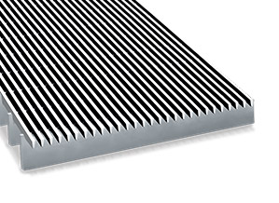

END OF TECH-CHECKING LIST

