The content of the Tech-Check Lists is based on our specs and MASTERSPEC®

tech-check specs interiors I Division 06

This is a template, so some items will apply to your project, and others won’t or will be missing.

When using the list, make the changes needed for your project.

DIVISION 06 - WOOD, PLASTICS, AND COMPOSITES
◻ | 06053 - MISCELLANEOUS ROUGH CARPENTRY
- This section mainly specifies concealed carpentry used for supporting, shimming, or other auxiliary functions.
- Miscellaneous carpentry is tagged either as preservative treated (i.e., when in touch with concrete) or fire-retardant treated where required by code (i.e. concealed blocking or nailers).
- Wood is either fire-rated or preservative-treated, not both.
- Plywood utility panels are tagged as fire-treated and not painted so marks are legible for inspection.
- LEED PROJECTS: Requirements and Submittals included at the beginning of the section.
◻ | 064111 - PLYWOOD OR BOaRD (MDF) paneling
- This section specifies wood composite board or plywood paneling, painted or with transparent finish.
- Miscellaneous carpentry is tagged either as preservative treated (i.e., when in touch with concrete) or fire-retardant treated where required by code.
- Wood is either fire-rated or preservative-treated, not both.
- Plywood utility panels are tagged as fire-treated and not painted so marks are legible for inspection.
- LEED PROJECTS: Requirements and Submittals included at the beginning of the section.
◻ | 064113 - wood-veneer-FACED ARCHITECTURAL CABINETS - see images at the end of this list
- Grade is AWI Premium.
- Construction: Frameless.
- Door and Drawer Front: Flush overlay.
- Exposed Surfaces: Wood Veneer - Include the following in the specs or the drawings:
- If in the Project there is paneling with the same veneer, tab the cabinetwork veneer as “Match Paneling.”
- Otherwise, the following note in the drawings or specs:
- Exposed surfaces:
- Wood species.
- Cut.
- Grain direction.
- Matching of veneer leaves.
- Veneer matching within the panel face.
- Semi-exposed surfaces: Melamine (thermoset decorative panels).
- Finishes are shop applied:
- Transparent Finish: Pre-catalyzed lacquer.
- Sheen: Flat, satin, semi-gloss, gloss.
- Transparent finish is either clear or stained to add color.
- Cores are MDF:
- Basis of Design Product: MDF by Rosebug, formaldehyde-free.
- LEED PROJECTS: Requirements and Submittals included at the beginning of the section.
◻ | 064116 - PLASTIC-LAMINATE-FACED ARCHITECTURAL CABINETS
- Grade is AWI Custom.
- Construction: Frameless.
- Door and Drawer Front: Flush overlay.
- Exposed Surfaces:
- Exposed surfaces: Plastic Laminate - grades are indicated in the specs.
- Semi-exposed surfaces: Melamine (thermoset decorative panels).
- Cores are MDF:
- Basis of Design Product: MDF by Rosebug, formaldehyde-free.
- LEED PROJECTS: Requirements and Submittals included at the beginning of the section.
◻ | 064216 - FLUSH WOOD PANELING
- This section specifies veneer-faced wood paneling, with transparent finish, stained or clear.
- Size and type of samples are applicable to the Project.
- If mockups are required, description is in the specs, location is in the Drawings.
- Paneling Rules: If there is other woodwork in the project with the same veneer as the paneling, the woodwork veneer in the other locations is described as “Match Paneling”.
- Grade is AWI Premium.
- Joints: Reveal size or describe inserts.
- Frames.
- Wood Veneer - Include the following in the specs or the drawings:
- Wood species.
- Cut.
- Grain direction.
- Matching of veneer leaves.
- Veneer matching within the panel face.
- Finishes are shop applied:
- Transparent Finish: Pre-catalyzed lacquer.
- Sheen: Flat, satin, semi-gloss, gloss.
- Transparent finish is either clear or stained to add color.
- Cores are MDF:
- Basis of Design Product: MDF by Rosebug, formaldehyde-free.
- Installation is by Z clips (preferable) or wood hanging strips.
- LEED PROJECTS: Requirements and Submittals included at the beginning of the section.
◻ | 066411 - GLASS-FIBER REINFORCED PLASTIC (FRP) PANELING
- This section specifies wall panels at utilitarian spaces like janitor closets.
  - Basis of Design Manufacturer: Marlite FRP Wall Panels.
- Include color and type of panels in the Drawings.
- LEED PROJECTS: Requirements and Submittals included at the beginning of the section.
◻ | 064600 - wood trim
- This section specifies wood wall base and miscellaneous trim, including frames.
- If wood base is at wood-veneer-paneling, core is MDF and AWI Grade and veneer match paneling.
- NOTE: Solid wood looks different from veneer - cuts are not the same, so it does not look the same.
- If wood base is not at wood paneling:
- Veneered Trim: Core is MDF and veneer is your choice.
- AWI Grade Custom or Premium.
- Transparent Finish: Pre-catalyzed lacquer.
- Solid Wood Trim: Indicate species, transparent finish as above.
- AWI Grade Custom or Premium.
- Opaque Finish: MDF, painted.
- AWI Grade: Custom.
- LEED PROJECTS: Requirements and Submittals included at the beginning of the section.

END OF TECH-CHECK LIST

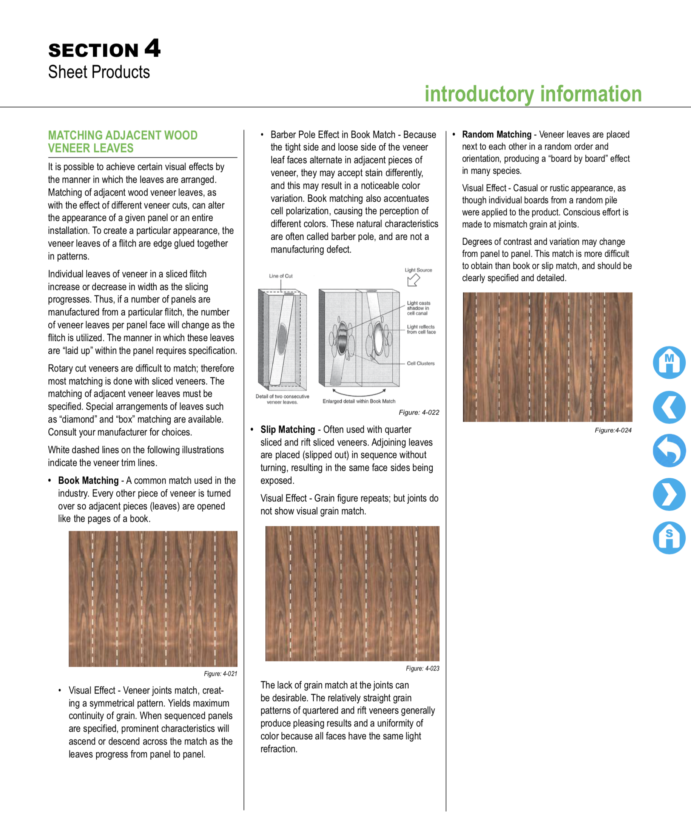
FROM THE AWI Standards - Arrangement of veneers
