The content of the Tech-Check Lists is based on our specs and MASTERSPEC®.

tech-check specs interiors I Division 10

This is a template, so some items will apply to your project, and others won’t or will be missing.

When using the list, make the changes needed for your project.

DIVISION 10 - SPECIALTIES
◻ | 101100 - VISUAL DISPLAY UNITS
- This section specifies marker boards boards wall mounted.
- Basis of Design Manufacturer: Claridge (glass marker boards and porcelain enamel sheet) . https://claridgeproducts.com/build/products/home/
- The dimensions of the board are indicated on the drawings if not in the specs.
- Accessories such as chalk-trays, backboard panels, trim, etc. are indicated on the drawings or the specs.
- Sliding components, if any, are indicated on the Drawings and included in the spec.
- Installation method(s) are indicated on the section.
- LEED PROJECTS: Requirements and Submittals included at the beginning of the section.
◻ | 102113.14 - STAINLESS-STEEL TOILET COMPARTMENTS
 | - This section specified stainless steel toilet compartments.  - Basis of Design Manufacturer: Bradley https://www.bradleycorp.com/toiletpartitions/stainless-steel-partitions  - ALL TOILET COMPARTMENTS IN RWW ARE SPECIFIED “OVERHEAD BRACED/FLOOR MOUNTED because that is the type that is easiest to install without wabbles.  - “Verify field dimensions”paragraph is included in the section.  - The product specificed has gap-free option when availlable.  - LEED PROJECTS: Requirements and Submittals included at the beginning of the section. | 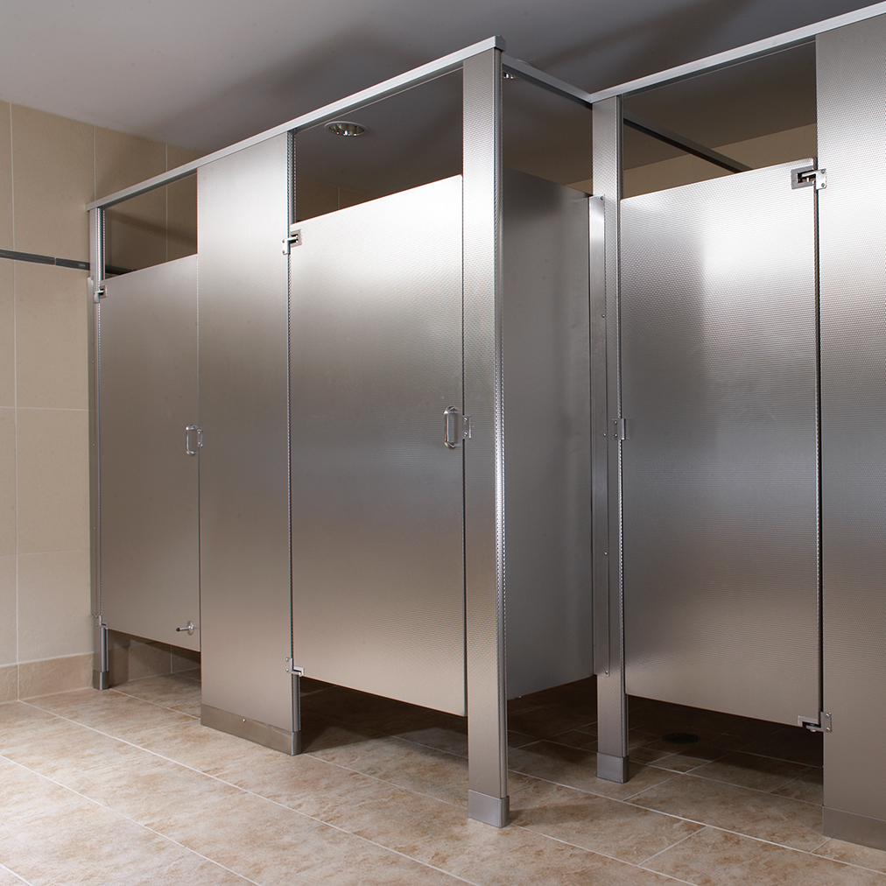
◻ | 102113.17 - PHENOLIC-CORE TOILET COMPARTMENTS
 | - This section specifies phenolic-core toilet compartments.  - Basis of Design Manufacturers: Bobrick or Bradley. https://www.bradleycorp.com/toiletpartitions/solid-phenolic-core-partitions  - ALL TOILET COMPARTMENTS IN RWW ARE SPECIFIED “OVERHEAD BRACED/FLOOR MOUNTED because that is the type that is easiest to install without wabbles.  - “Verify field dimensions”paragraph is included in the section.  - The product specificed has gap-free option when availlable.  - LEED PROJECTS: Requirements and Submittals included at the beginning of the section. | 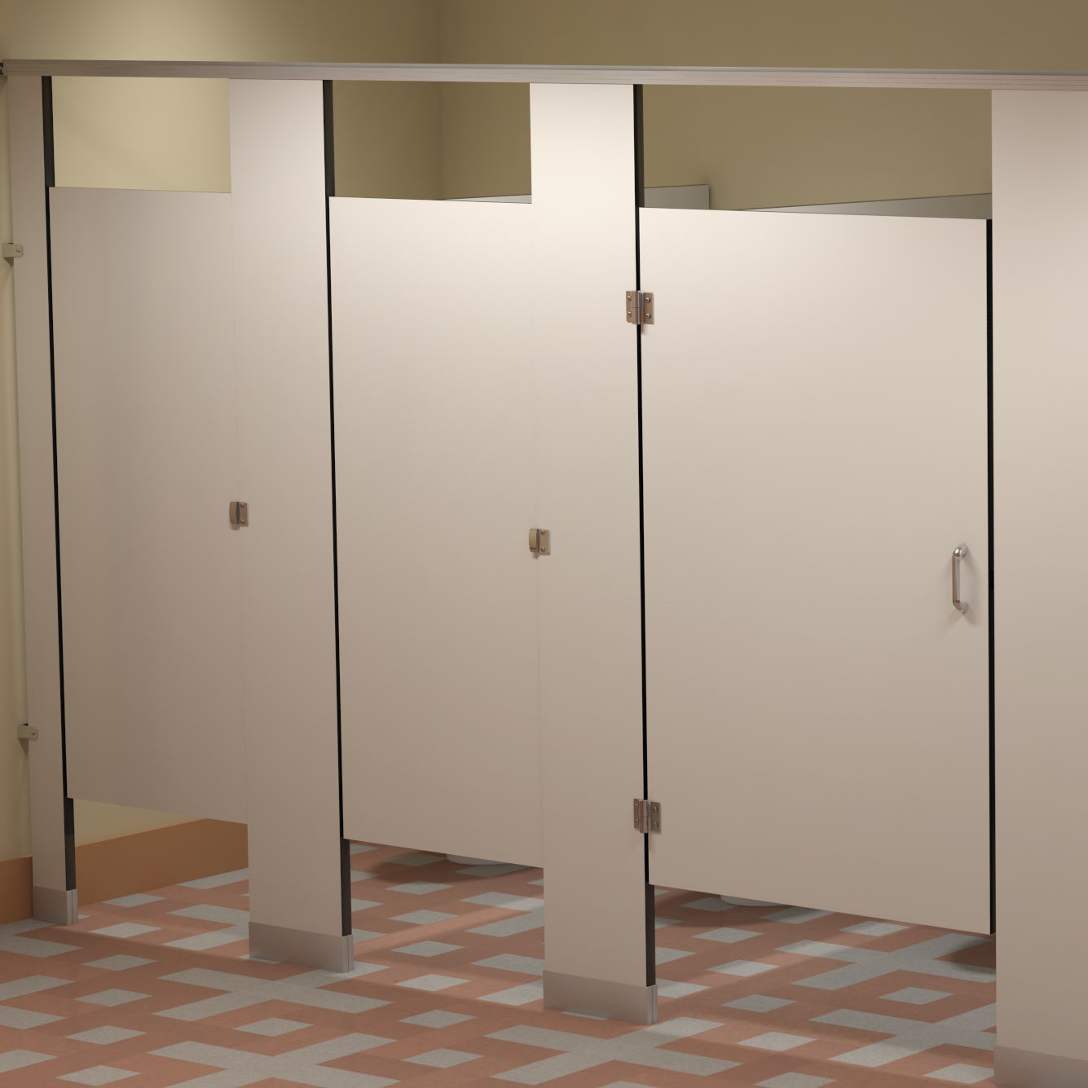
◻ | 104413 - FIRE PROTECTION CABINETS
 | - This section specifies fire protection cabinets for portable fire extinguishers, surface mounted, semi-recessed and fully recessed.  - Basis of Design Manufacturer: Larse’s or JL. http://www.larsensmfg.com/home;  - Section includes white enameled finish (to be field painted to match the wall) or stainless steel - as applicable to project.  - Partition thickness is coordinated with type of cabinet and details. If cabinets are installed in rated partitions, detail is included.  - Installation for type of cabinets specified is included in the section- window (if any), letering, etc.  - FIRE EXTINGUISHERS are typically 5 pounds. | 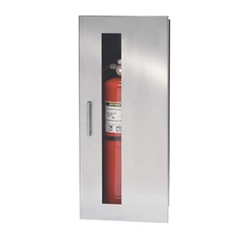
◻ | 105113 - METAL LOCKERS
 | - This section specifies WELDED metal lockers. These can be standard models or special tpes, like quiet lockers or good looking ones.  - Basis of Design Manufacturer (Standard lockers and Quiet lockers): Republic https://republicstorage.com/store/corridor_lockers?lockers=1  - Lead time in lockers is very important. Verify they are available before specifying.  - Field dimensions verification paragraph is included in the section.  - Arrangement of lockers is in the drawings; Size and type is in the specs.  - Requirement for base or for legs is included.  - Type of lock, numbers, vents, are included.  - LEED PROJECTS: Requirements and Submittals included at the beginning of the section. | 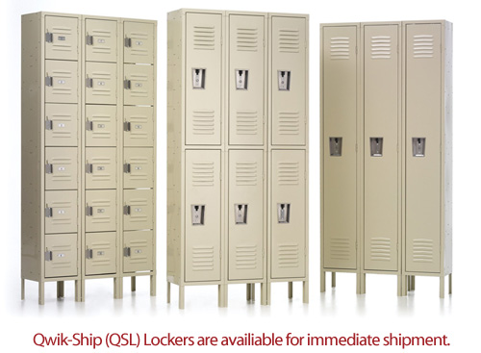
◻ | 102123 - CUBICLE CURTAINS AND TRACK
 | - This section specifies Cubicle-curtain tracks and carriers AND CURTAINS.  - Basis of Design Manufacturer: Construction Specialites.  - Type of track is included (material accessories, etc) is included.  - IF curtains are not provided by the Owner, then they should be included in the section and on the Drawings under finishes.  - Fabric type and/or mesh, construcion, color and pattern, and length of curtains, are included in the section.  - Installation (surface mounted or suspended is included in the section.  - LEED PROJECTS: Requirements and Submittals included at the beginning of the section. | 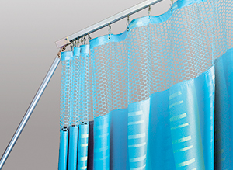
◻ | 102233 - ACCORDION FOLDING PARTITIONS
 | - This section specifies manually or electrical operated accordion folding partitions, rated and non-rated.  - Basis of Design Manufacturer Glass: CRL US Aluminum. http://www.crl-arch.com/#ab  - Basis of Design Manufacturer Rated: Won-Door. http://wondoor.com/  - Basis of Design Manufacturer: Hufcor http://www.hufcor.com/products/accordion-doors/#downloads  - Acoustical performance is included.  - Seismic requirements for delegated design work are included.  - Fire resistance requirements are included.  - Surface burning requirements are included.  - Suspension system is included.  - Acoustical field testing is included.  - Check finishes in the spec section.  - LEED PROJECTS: Requirements and Submittals included at the beginning of the section. | 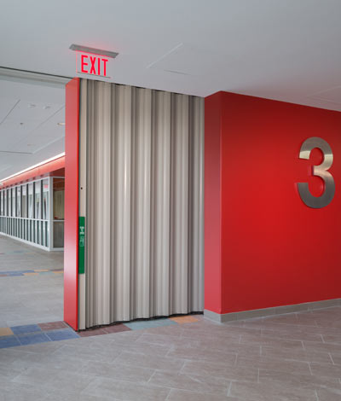
◻ | 102800 - TOILET, shower, and custodial ACCESSORIES
 | - This section specifies accessories for public-use bathrooms and showers; under lavatory guards; and custodial accessories.  - Basis of Design Manufacturer: Bobrick.  - Basis of Design Product under lavatory guards: IPS Truebro® Lav Guard® 2 Undersink Piping Covers  - Section includes the following:  - General requirements for toilet accessories that are shown on the Drawings.  - General requirements for grab bars that are shown on the Drawings.  - Miscellaneous Accessories: Coat hooks, folding shelfs, diaper changing unit.  - Accessories for showers: Curtain rod, curtains shower seat, shelves, towel hooks, towel bar, bench for outside the shower where people undress and dress, hair dryer.  - Accessories for custodial rooms: Floor sink and shelf with mop/broom holder.  - Check that details showing installation and location match the section.  - LEED PROJECTS: Requirements and Submittals included at the beginning of the section. | 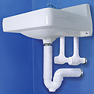

END OF TECH-CHECKING LIST

