The content of the Tech-Check Lists is based on our specs and MASTERSPEC®

tech-check specs interiors I Division 12

This is a template, so some items will apply to your project, and others won’t or will be missing.

When using the list, make the changes needed for your project.

DIVISION 12 - FURNISHINGS
◻ | 122413 - ROLLER WINDOW SHADES
 | - This section specifies roller window shades, manually or motor operated, one or two rollers.  - Basis of Design Manufacturer: MecoShade  - If motor operated the requirement of coordination with electrical works included  - Details match the spec.  - Field measurements requirement is included.  - Shades are included and match the Drawings.  - LEED PROJECTS: Requirements and Submittals included at the beginning of the section. | 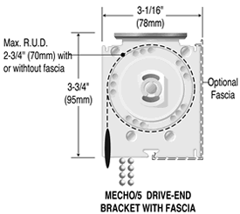
◻ | 123623.13 - PLASTIC-LAMINATE-CLAD COUNTERTOPS S
 | - This section specifies plastic -laminate-clad countertops with MDF cores.  - Basis of Design Manufacturer for Core: ROSEBURG (formerly Sierra Pine)  - Field measurements requirement is included.  - Core: MDF: Moisture resistant, flame retardant and no-added formaldehyde (NAF)  - Description of backsplash and edge in specs matches details.  - LEED PROJECTS: Requirements and Submittals included at the beginning of the section. | 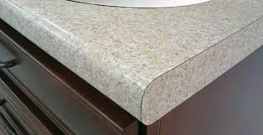
◻ | SECTION 123661.16 - SOLID SURFACING COUNTERTOPS
 | - This section specifies solid surfacing countertops and backsplashes.  - Solid surface material characteristics are included.  - Field measurements requirement is included.  - Description of backsplash and edge in specs matches details.  - Installation instructions match details.  - LEED PROJECTS: Requirements and Submittals included at the beginning of the section. | 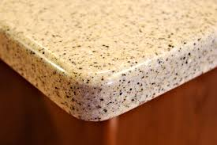
◻ | 123661.19 - QUARTZ AGGLOMERATE COUNTERTOPS
 | - This section specifies quartz countertops and backsplashes.  - Quartz material characteristics are included.  - Field measurements requirement is included.  - Description of backsplash and edge in specs matches details.  - Installation instructions match details.  - LEED PROJECTS: Requirements and Submittals included at the beginning of the section. | 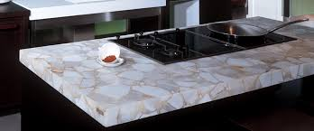
 | 124813 - ENTRANCE FLOOR MATS AND FRAMES
 | - This section specifies resilient entrance mats with surface mounted or recessed frames.  - Basis of Design Manufacturer: Construction Specialties.  - Field measurements requirement is included.  - Coordination with concrete work in new buildings with recessed frames is included.  - Description of frames and match in specs matches details.  - Installation instructions match details.  - LEED PROJECTS: Requirements and Submittals included at the beginning of the section. | 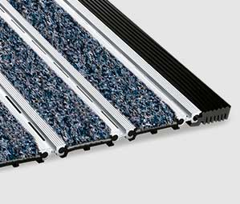
 | 124816 - ENTRANCE FLOOR GRILLES
- This section specifies resilient entrance mats with surface mounted or recessed frames.
- Basis of Design Manufacturer: Construction Specialties.
- Field measurements requirement is included.
- Coordination with concrete work in new buildings with recessed frames is included.
- Description of frames and match in specs matches details.
- Installation instructions match details.
- LEED PROJECTS: Requirements and Submittals included at the beginning of the section.

END OF TECH-CHECKING LIST

